 Drain node in preparation for maintenance same as kubectl drain.

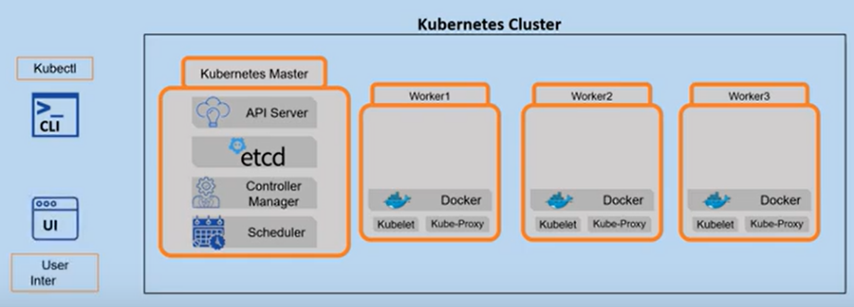

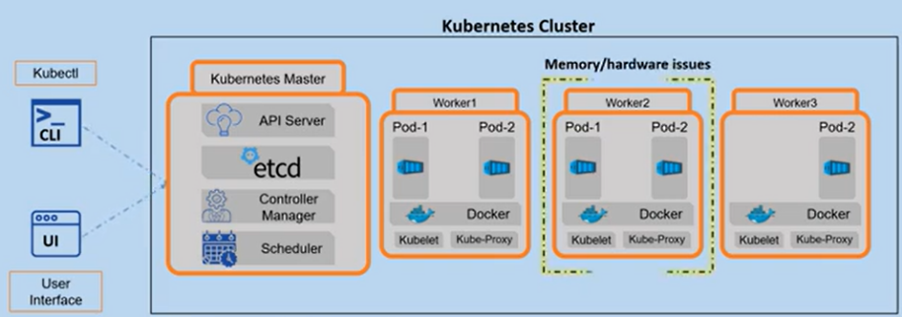

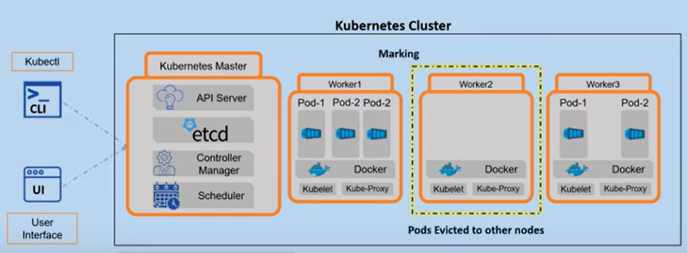

Cordon will mark the node as unschedulable.

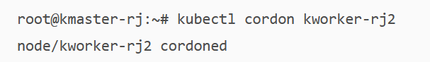 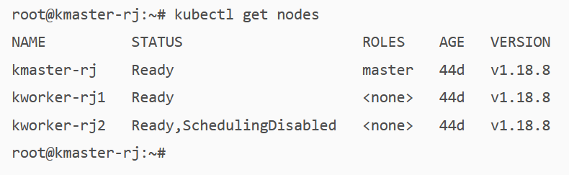  
Uncordon will mark the node as schedulable.